# EKS Connector

1. ***Setting up AWS Systems Manager for hybrid environments***

* Step 1: Complete general Systems Manager setup steps
* Step 2: Create an IAM service role for a hybrid environment
  + AmazonSSMManagedInstanceCore
* Step 3: Create a managed-instance activation for a hybrid environment🡪activition-code, activation-id

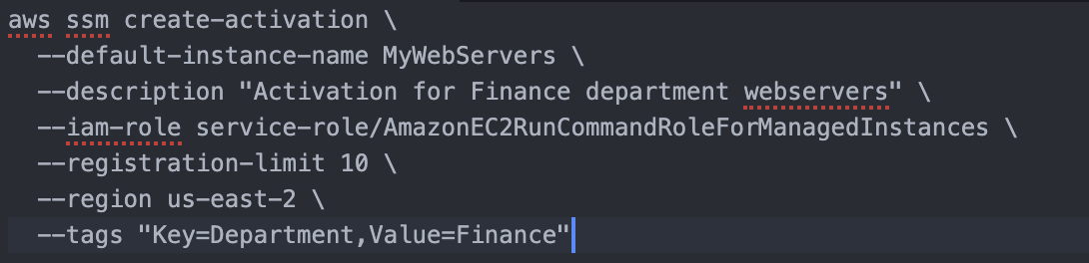

* Step 4: Install SSM Agent for a hybrid environment (Linux)

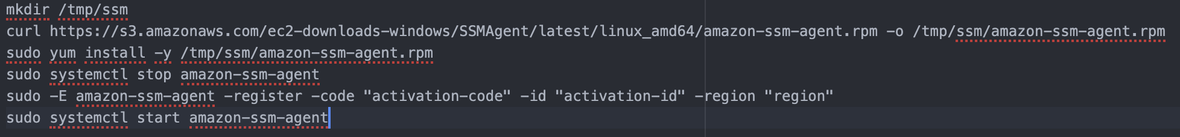

1. ***EKS Connector流程***

* Step 0: Amazon EKS Connector considerations

[Amazon EKS Connector - Amazon EKS](https://docs.aws.amazon.com/eks/latest/userguide/eks-connector.html#connect-cluster-reqts)

* Step 1: Creating the Amazon EKS connector agent role

[Amazon EKS connector IAM role - Amazon EKS](https://docs.aws.amazon.com/eks/latest/userguide/connector_IAM_role.html#create-connector-role)

* Step 2: Registering the cluster



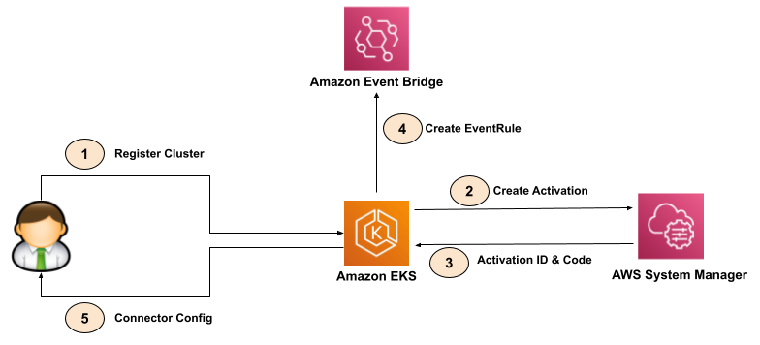

* Step 3: Applying the manifest file
  + eks-connector.yaml

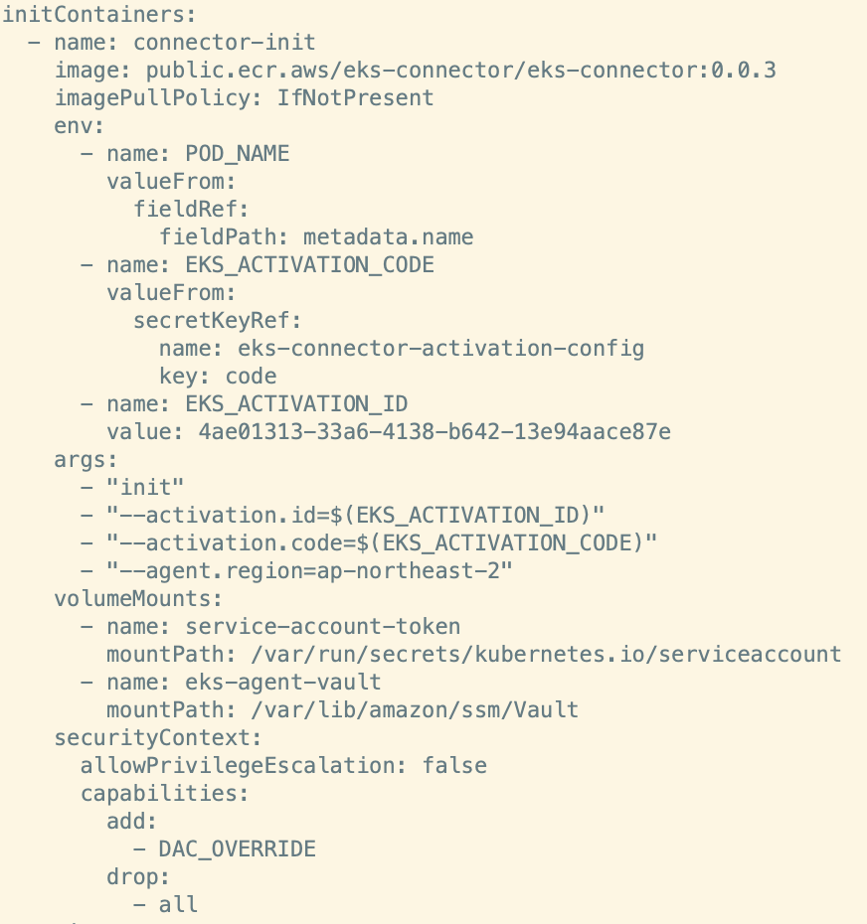

注册

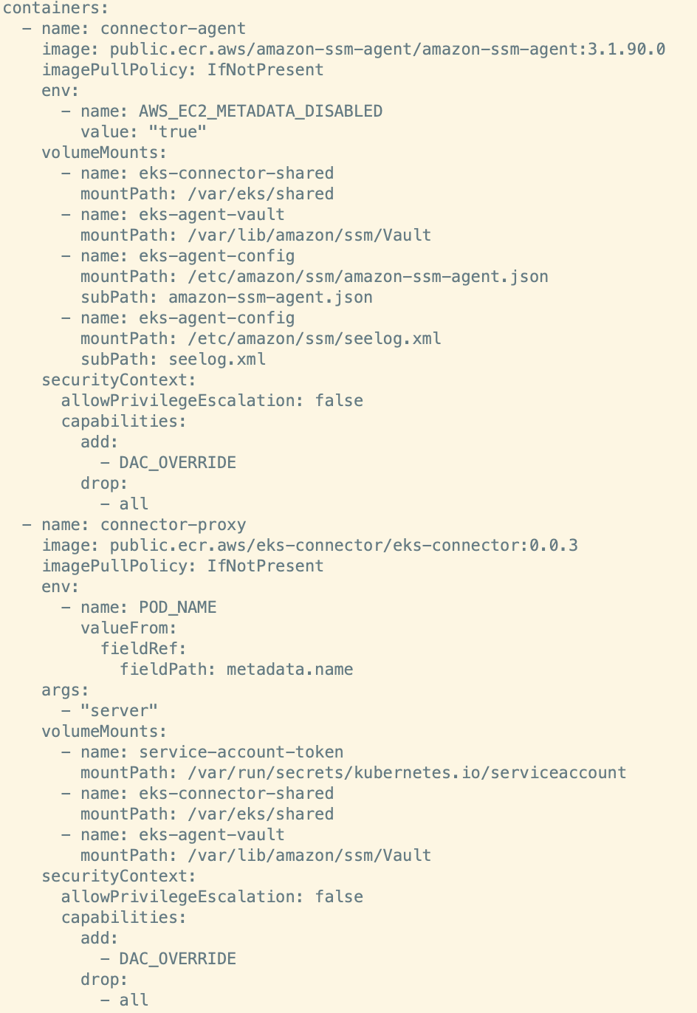

启动服务

* + eks-connector-clusterrole.yaml

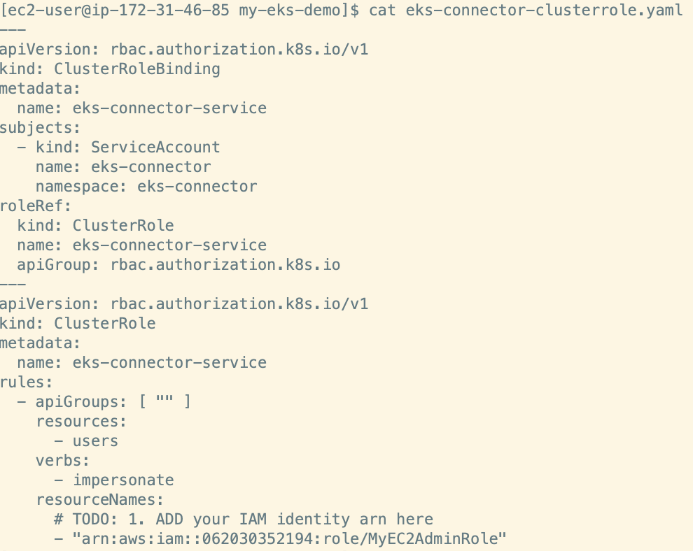

* + eks-connector-console-dashboard-full-access-group.yaml

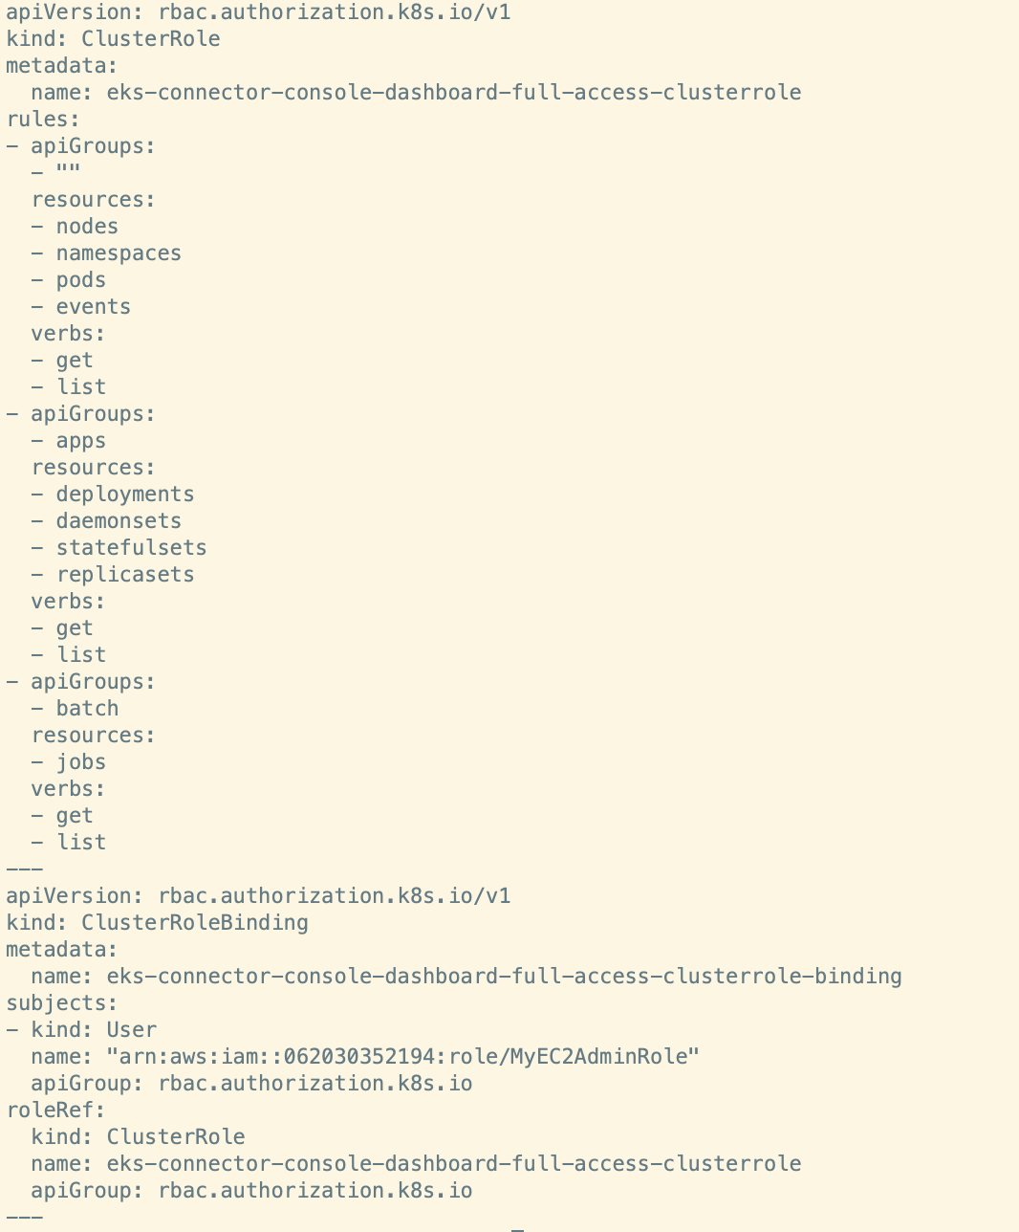

* Step 4: Start Non-Interacive Session

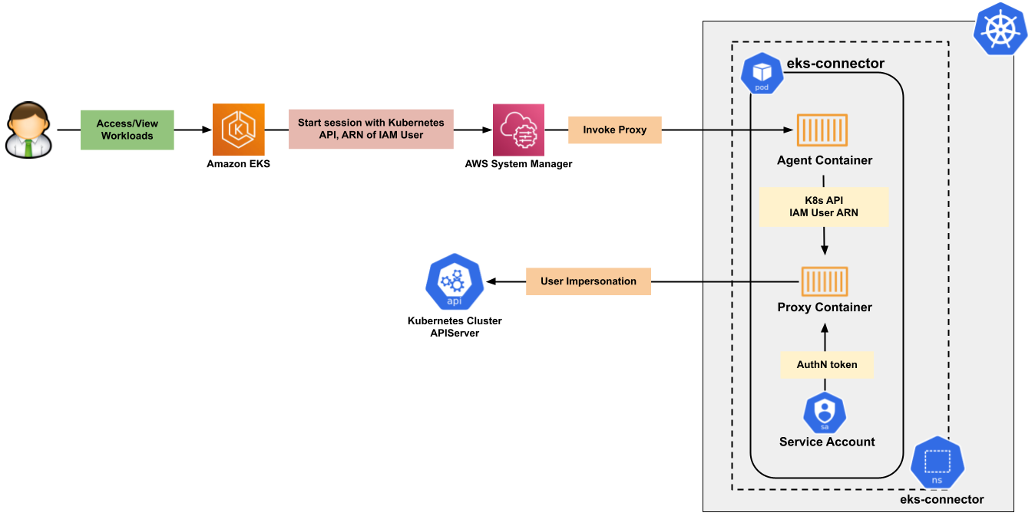

* Step 5: Demo

~]$ cd my-eks-demo/; rm -rf eks-connector*;

~]$ scp -i id_rsa_test ec2-user@3.37.169.201://home/ec2-user/my-eks-

~]$ scp -i id_rsa_test ec2-user@3.37.169.201://home/ec2-user/my-eks-demo/eks-connector-clusterrole.yaml .

~]$ scp -i id_rsa_test ec2-user@3.37.169.201://home/ec2-user/my-eks-demo/eks-connector-console-dashboard-full-access-group.yaml .

+ replace IAM arn: arn:aws:iam::062030352194:root

+ Apply manifests

+ After applied manifests, check ‘Hybrid Activations’ page and ‘Session Manager’ page as well as ‘EKS Cluster’ page

1. ***Reference:***

* [aws/amazon-eks-connector (github.com)](https://github.com/aws/amazon-eks-connector)
* [Amazon EKS Anywhere & EKS Connector | by Gokul Chandra | Medium](https://gokulchandrapr.medium.com/amazon-eks-anywhere-eks-connector-600953aaa42d)

# Comparison between ACK and EKS

1. ***Cluster Creation***

|  |  |  |
| --- | --- | --- |
| 对比项 | 阿里云ACK | AWS EKS |
| 友好性 | 1. 有多种选择时，会在旁边给予提示和说明  2. 开通确认界面提示费用和各项状态 | 无 |
| 便利性 | CRI及其他组件可以一键部署 | 需要手动部署 |
| 灵活性 | 1. NodeGroup并非由ASG进行控制  2.节点都在内网，缺少灵活性 | 创建时指定Launch Template，灵活性更好 |

1. ***CNI***

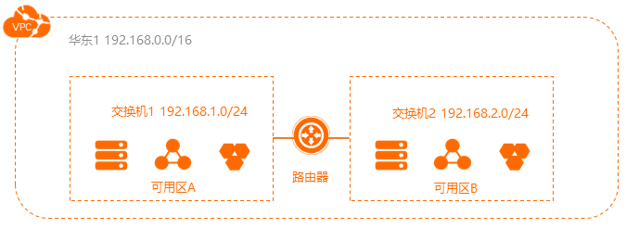

|  |  |  |  |
| --- | --- | --- | --- |
| 对比项 | 阿里云Flannel | 阿里云Terway | AWS CNI |
| 性能 | 配合阿里云VPC路由，Pod地址为虚拟地址，存在NAT转换损耗。 | Pod地址即为VPC中地址，无NAT损耗支持独占ENI模式，几乎无损。 | 同Terway |
| 安全 | 不支持使用网络策略Network Policy。 | 支持使用网络策略Network Policy。 | 同Flannel，需要安装插件支持Network Policy |
| 地址管理 | 节点维度划分地址段，大规模集群下地址浪费多。 | 无需按节点分配地址段，随用随分配，地址无浪费。 | 同Terway |
| SLB | SLB后端不能直接对接Pod，需要通过NodePort转发。 | SLB后端直接对接Pod，支持业务无中断升级。 | 同Terway |
| Kube-Proxy | 需要 | Service的网络采用eBPF替换原有的kube-proxy模式 | 同Flannel |
| IP Prefix | 不支持 | 不支持 | 支持 |

1. ***Reference:***

[aws/amazon-vpc-cni-k8s: Networking plugin repository for pod networking in Kubernetes using Elastic Network Interfaces on AWS (github.com)](https://github.com/aws/amazon-vpc-cni-k8s)

[Assigning prefixes to Amazon EC2 network interfaces - Amazon Elastic Compute Cloud](https://docs.aws.amazon.com/AWSEC2/latest/UserGuide/ec2-prefix-eni.html)